If you are working from home you can have items shipped to your home with appropriate documentation.

Orders shipping to non-UF addresses require:

1. Justification explaining why the purchase needs to be shipped to the home including how the items are being used there.
   * Examples of acceptable justification:  Mailing supplies to recruit research participants
   * Unacceptable justification:  COVID
2. Departments ensure unused purchases are returned to UF as items purchased are the property of UF.NOTE:  Departments may have unique requirements beyond these stated so check with your department

To add a one-time ship to address in myUF Marketplace, begin by clicking Proceed to Checkout from your shopping cart. Once you are there, locate the Ship To address field and click edit. It should display a screen similar to the one below that includes the current shipping address or the ability to select a new one. Type in the words “one time” and click search.

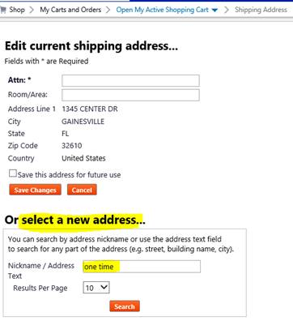

Once you have clicked search, press the orange Use button as shown below to edit the fields of the One Time Ship To address.

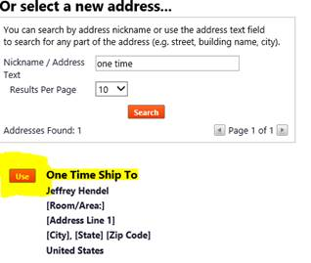

Upon clicking Use a new window will pop up allowing you to fill in the fields of the one-time ship to address. Once it is filled out, click use and it will populate in the Ship To field and bring you back to your shopping cart checkout screen.

