Attaching Documentation To PCard Transactions Via OnBase
PCard supporting documentation is electronically “attached” to PCard transactions at the time they are verified or approved in myUFL.
Use Google Chrome for the best functionality.

NAVIGATION
Use the following navigation to get to the Reconcile Statements page in myUFL

- Click Main Menu
- Click Financials
- Click Purchasing
- Click Procurement Cards
- Click Reconcile
- Click Reconcile Statement

PROCESS
- Save the image of the documentation to be attached to the transaction.
  - The saved documentation can be things such as a scanned receipt, an email, a web page, or an electronic invoice.
  - More than one document can be attached to a transaction.
- Identify the transaction to be verified or approved.
- Click on the Paperclip icon.

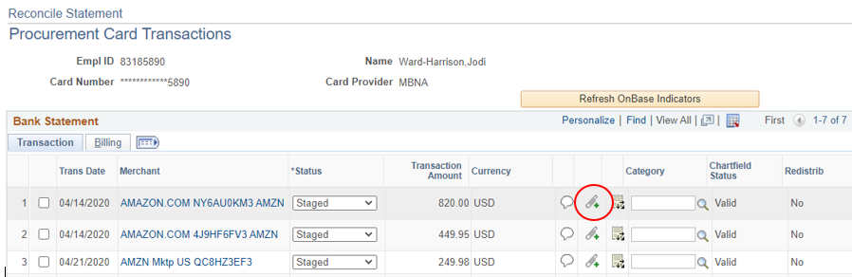

- You will be redirected to OnBase
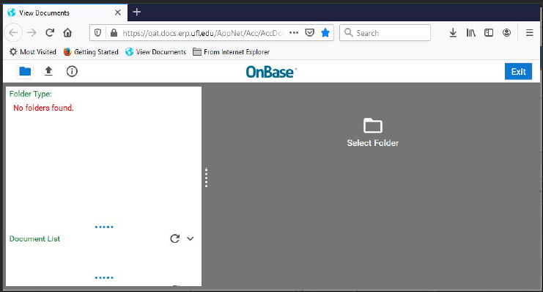
- Click the Upload File button.
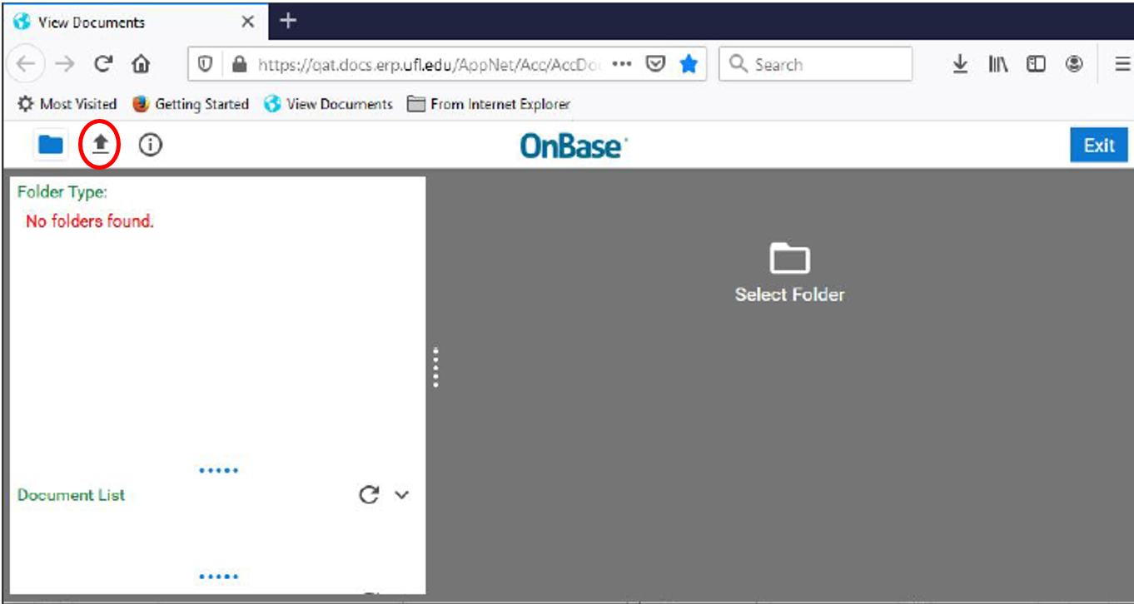

- Click the Choose file or Browse button depending upon your Browser
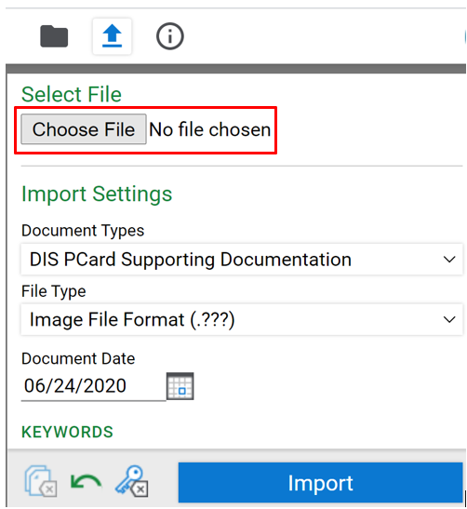
- Select the document to be attached.
- Click the Import button.
- Click the Exit button. Or, to add additional documents click the up arrow again.
- Click on the OnBase Refresh Indicator icon to confirm the document(s) were attached.
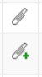 | When there is NOT a plus sign documents are attached.
 | Green Plus sign indicates there are NO attachments
- Complete the reconcile/approve process. See the Reconciling and/or Approving PCard Transactions Instruction Guide.
- Click the Save button.
- To Delete an attachment, under “Document List” select the document to be deleted, right click and select “Delete”.

