Paid Charges Aging Report

The PCard Paid Charges Aging Report is a historical report of charges by cardholder, by month.

The Aging Report is a helpful tool for internal control. There is a certification statement at the bottom of the report where Cardholders and Reconcilers/Approvers sign to certify that the charges are for legitimate UF business. It is a best business practice to have cardholders sign the report each month.

The report can also be used to find vouchers in error.

A "PCard Paid Charges Aging Report" is generated in myUFL via Enterprise Reporting.

The report is found using the following navigation:

myUFL >Main Menu >Enterprise Analytics >Access Enterprise Analytics a new window will open
>Team content > Financial Information >Purchasing >PCard Paid Charges Aging Report

TEAM CONTENT | 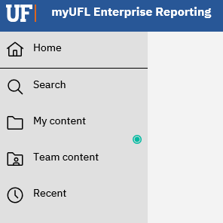
FINANCIAL INFORMATION | 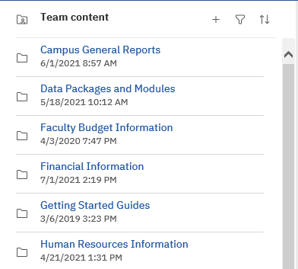
PURCHASING | 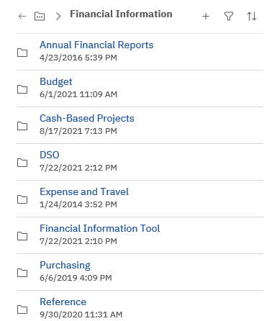
PCARD PAID CHARGES  AGING REPORT | 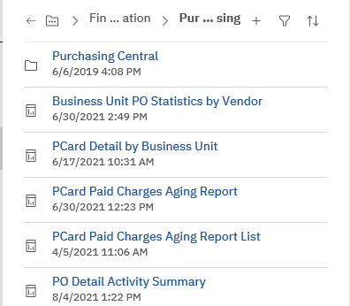

Select the month of the report to be viewed by using the drop-down window  Type in the calendar Year  Use the drop-down window to locate the four-digit Department ID  The box below will populate with all cardholders who have ever had a card in that BU  Select the cardholder(s) and then  - Use the "Select All" option at the lower right of the window to select all cardholders  - Select one cardholder by clicking on the cardholder's name  - Select more than one cardholder by holding down the Control key and clicking on individual names | 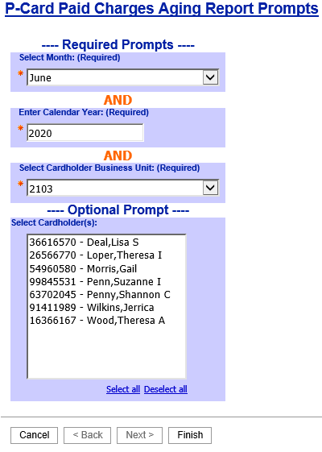  At the bottom of the page lick "Finish"

A separate report will return for each cardholder selected.

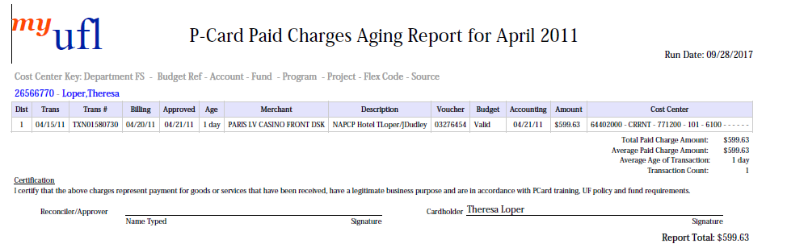
The approver and the cardholder should sign the Certification statement.

Review the report for line items/vouchers in the Budget Status "Error" and take appropriate action.

For information on correcting budget errors see HR’s Correcting Voucher Budget Errors
Instruction Guide.

